Whatsapp Follow Up
Step 1
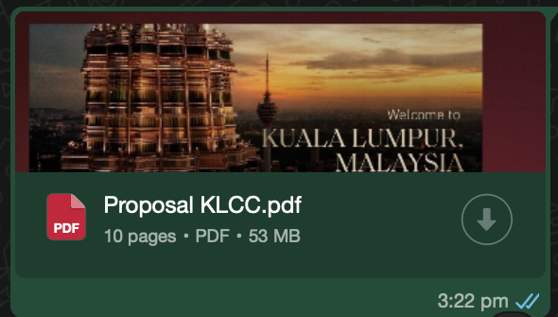
给别人有兴趣了 才介绍自己，没人想要知道我们是谁先 Step 1
-Proposal- ➕文案
Step 2
-Introduce yourself- Name, and Experience
*类似于老顾客，之前推了他项目，但是他没买成，然后再推新的项目*
⚠️Don’t click any links outside this chat.
Just read this message first.
Step 3
-Project Award
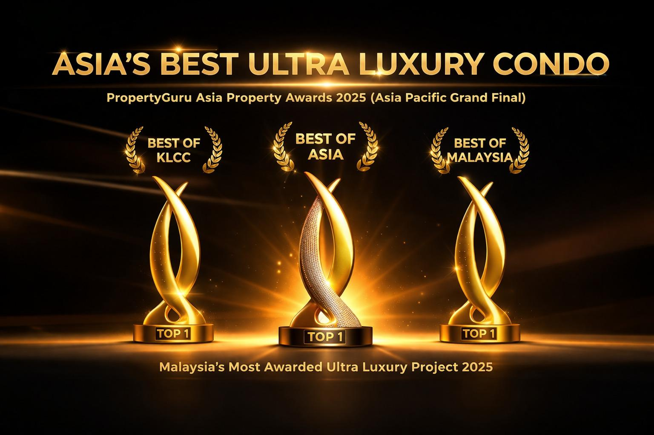
Bro, you are gonna want to see this🔥
Just saw the PropertyGuru Asia Awards 2025 Grand Final results and....

Our project completely SWEPT THE BOARD!
🏆BEST OF ASIA - Best Ultra Luxury Condo Development (Asia)
🏆BEST OF MALAYSIA - Best High-Rise Development Malaysia (Best of Malaysia)
🏆BEST OF KLCC - Best Ultra Luxury High-Rise Development (Central Region)

Curious about this project & want to know more？
Just reply “SHOW ME” and I’ll drop you instantly👍
You don’t have to reply to this message.
I just don’t want you to miss this opportunity if you are still considering property.
Poll Question
Is this your first-time investment Property?
Yes, first time
No, First time in Malaysia
Please read this before you sleep tonight.
Step 4
-Location -Big Map （Malaysia-Kuala Lumpur （KLCC）CBD area）
-CBD Area
-What is CBD Area
Summary Location
📪 Hi, just a gentle reminder that I’ve sent you some information earlier.
Let me know if you need me to resend or explain further.
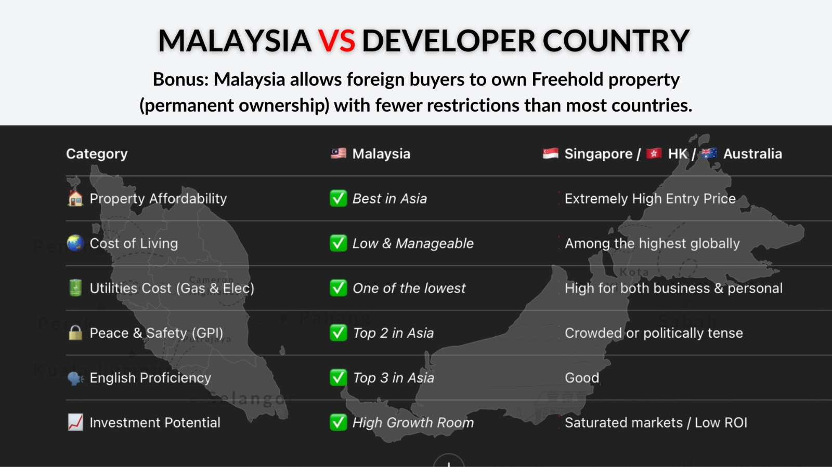
🔍 Why Global Rankings Matter for Investors

Before investing overseas, smart investors ask:

1️⃣ Is the country safe and stable?
2️⃣ Are property prices fair with growth potential?
3️⃣ Is communication with locals easy
4️⃣ Are living costs manageable?
5️⃣ Is the government transparent and policies stable?
6️⃣ Will this be a burden in a few years?

✅The most objective way to answer? Check global rankings from trusted sources

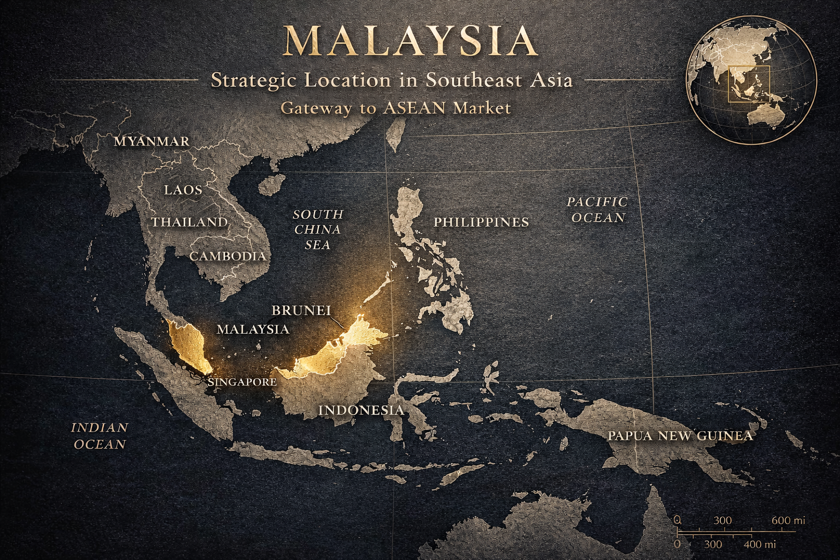
📍Located -Malaysia

If Singapore is too expensive,
If Hong Kong property prices are too high,
If Australia requires too high entry cost,

Malaysia becomes the perfect balance between price, yield and lifestyle.

In the heart of Asia,
Connected to major cities within a few hours flight,

✅Lower property price
✅Higher rental yield
✅Foreign ownership allowed,
✅ English-speaking environment,
✅International lifestyle with lower cost of living.

Malaysia is not just a place to buy property.
It is a strategic place to invest, live and grow wealth.
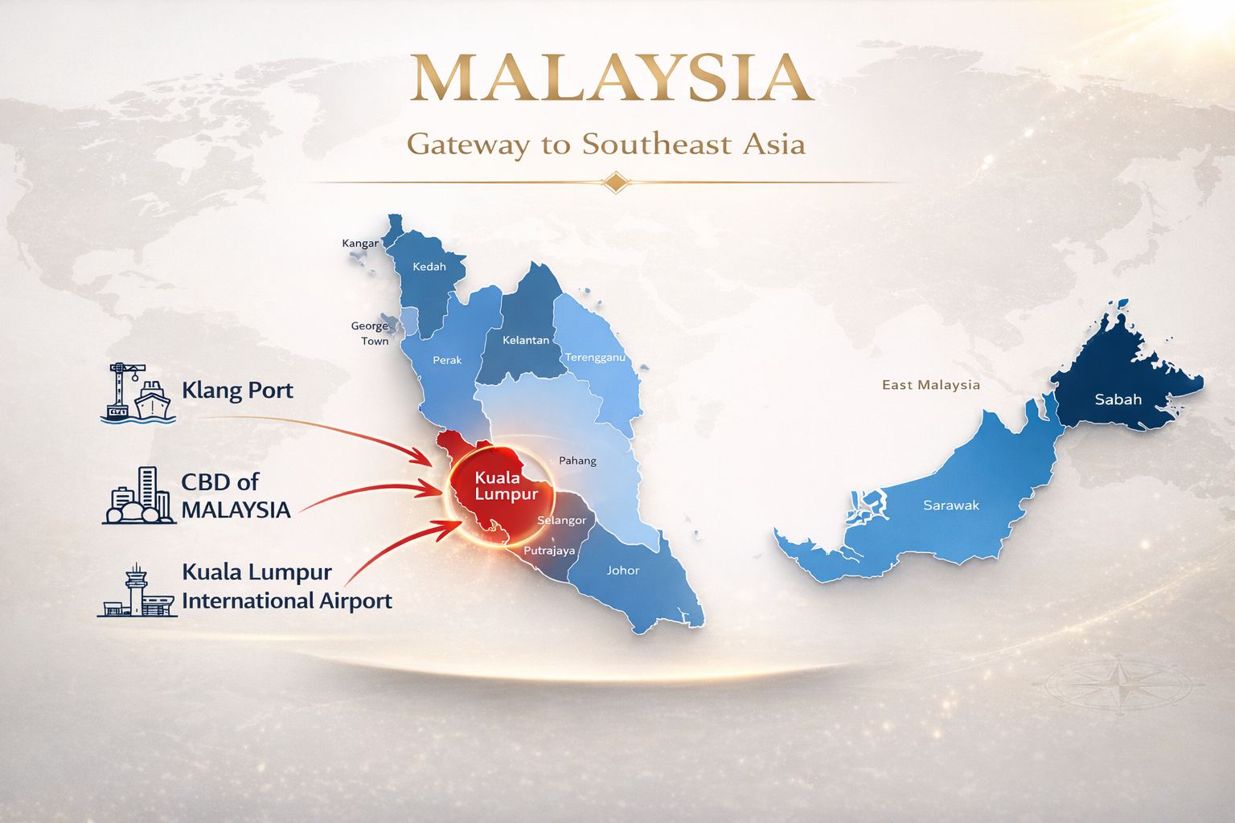
Kuala Lumpur Sea • Air • Trade • Economy
All Connected to Kuala Lumpur

When people talk about Malaysia,
they talk about Kuala Lumpur.

When businesses enter Malaysia,
they start from Kuala Lumpur.

When investors invest in Malaysia,
they choose Kuala Lumpur.

Because Malaysia starts from Kuala Lumpur.
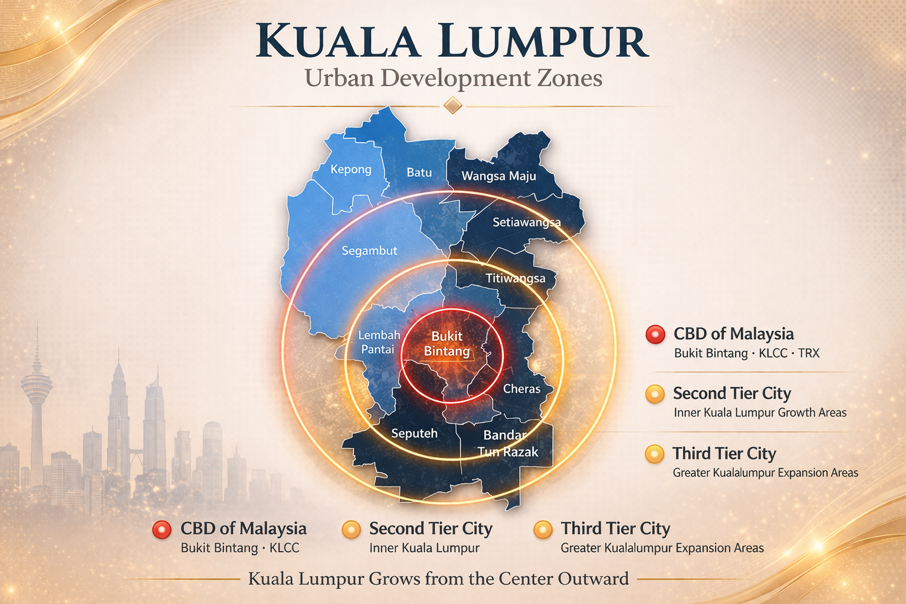
We are located in the CBD area,
the center of Kuala Lumpur and also the central hub of Malaysia.

Not every property has growth,
but every city grows around the CBD.

If the pricing is similar,
the smarter choice is always the better location.

Choose CBD. Choose Growth. Choose Opportunity.
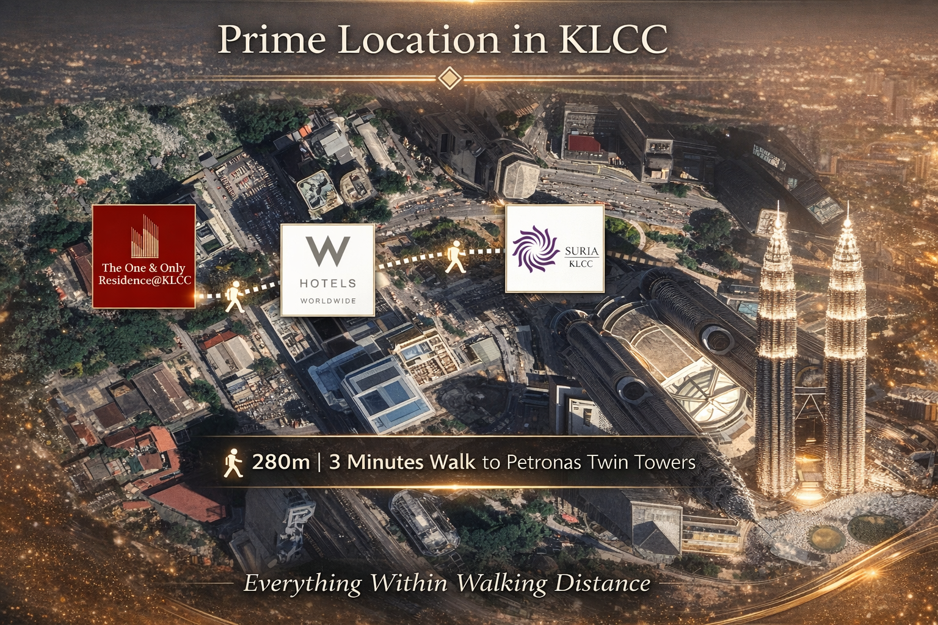
✨Malaysia CBD Area-KLCC: Only One CBD area in One Country✨

✨ KLCC CBD Golden Triangle Area✨
ONLY 280m Link Bridge to Petronas Twin Towers‼️

✈️Attractions and Landmarks
📍Petronas Twin Tower
📍KL Tower
📍KLCC China Town
📍Merdeka 118
📍Exchange 106 (TRX)

✨Amenities
🏙 Suria KLCC
🏙 Pavilion Kuala Lumpur
🏙 The Exchange TRX
🏙 Lot 10
What Is CBD Area?
🇸🇬Singapure- Marina Bay Sands
🇹🇭Thailand- Bangkok
🇹🇼Taiwan-Taibei
🇨🇳China-Beijin

A Central Business District (CBD) is the downtown core, commercial, and financial heart of a city, characterized by a high concentration of offices, banks, retail, and entertainment venues

That Mean，all opportunity around us 🏦🏦

🇲🇾Malaysia- KLCC🇲🇾

Not every project is in the CBD.
And not every CBD project is like this
📍Location Highlights📍
1)Strategic CBD Location
2)One of the most prime areas in Malaysia
3)Strong capital appreciation potential
4)High rental demand
5)Stronger entry price compared to other major cities
6)Currency advantage for foreign investors
If location is good, price is reasonable, and rental demand is strong, would this be something you would consider?
Step 5
-Price PSFT CBD Area
-KLCC Market Price
-Our Pricing RM1700
Summary Pricing Advantage
📪Just a quick follow-up on my previous message.
I understand you might be busy, but I’ll be here whenever you’re ready.
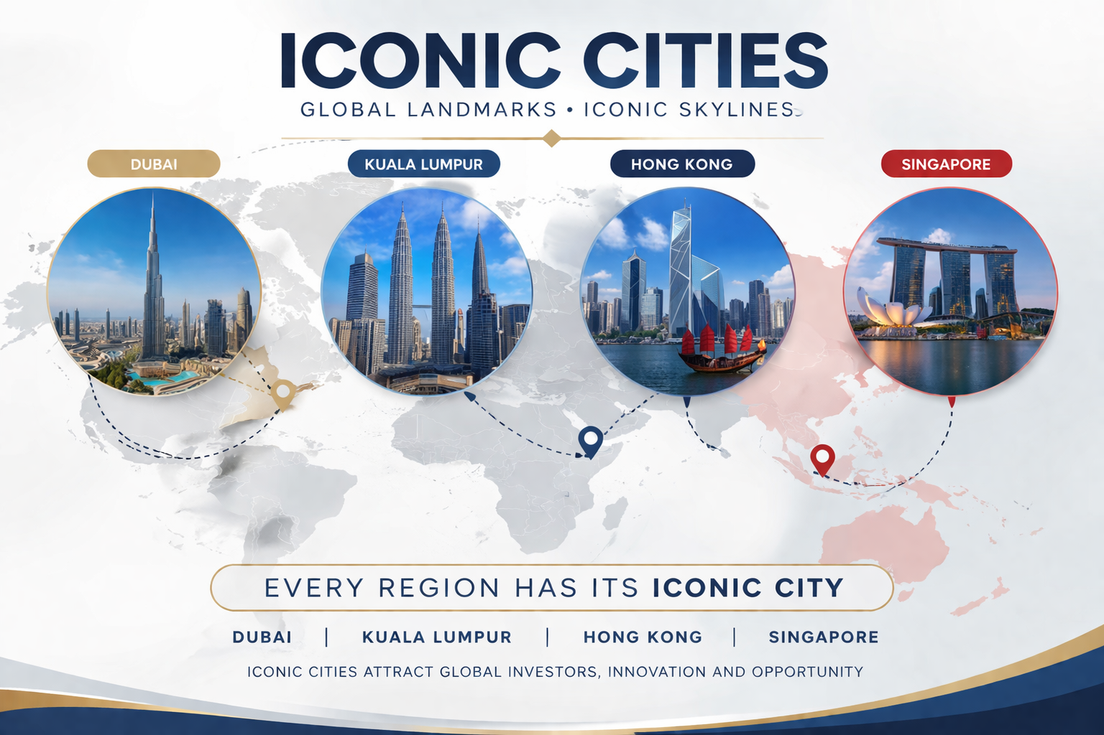
Investment Opportunity in Malaysia
🇲🇾Why smart investors are choosing Malaysia over places like Hong Kong, Singapore & Dubai?

💎 Malaysia = Quiet Tax Heaven
💎 Foreigners can own Freehold property
💎 No Inheritance Tax – 100% pass down to children
💎 No Annual Property Tax (only minimal charges)
💎 Tax only on Nett Rental Income
💎 No Wealth Tax
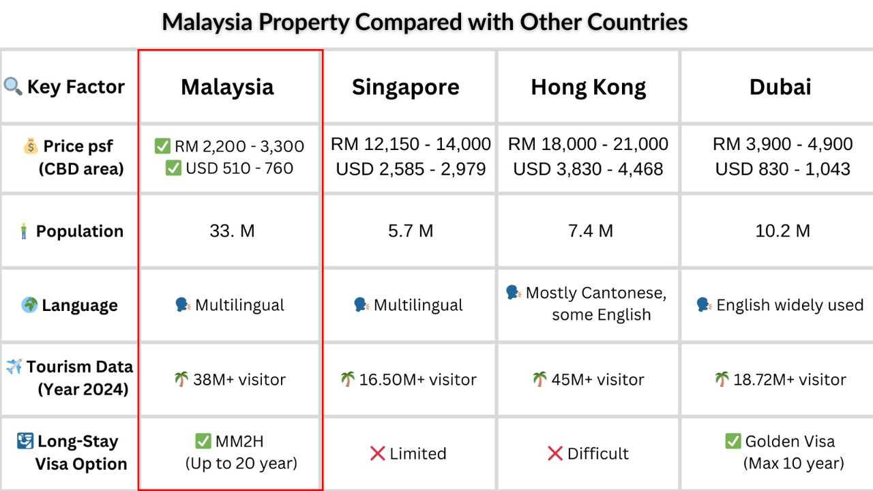
📉 Market Saturation
🇲🇾Malaysia:⭐⭐☆☆☆
🇸🇬 Singapore:⭐⭐⭐⭐☆
🇭🇰 Hong Kong:⭐⭐⭐⭐⭐
🇦🇪 Dubai:⭐⭐⭐☆☆

🧭 Market Opportunity
🇲🇾Malaysia:⭐⭐⭐⭐⭐️
🇸🇬 Singapore:⭐⭐⭐☆☆
🇭🇰 Hong Kong:⭐⭐☆☆☆
🇦🇪 Dubai:⭐⭐⭐☆☆
🚫Please don’t open this message unless you are still interested in owning a property 😄
Price per Sqft in Developed CBD Cities
🇸🇬Singapore – RM13,000 | USD 2,700
🇭🇰Hong Kong – RM20,000 | USD 4,200
🇸🇦Dubai – RM4,500 | USD 900

🇲🇾Malaysia KLCC – RM3,100 | USD 775 (Current Market)
Potential upside up to 76%

The One & Only Project – RM1,700 | USD 425
Potential upside up to 87%

That is an additional 11% upside compared to current KLCC prices.
This is the advantage of entering at the right price and the right timing.

Keep going, the numbers will surprise you
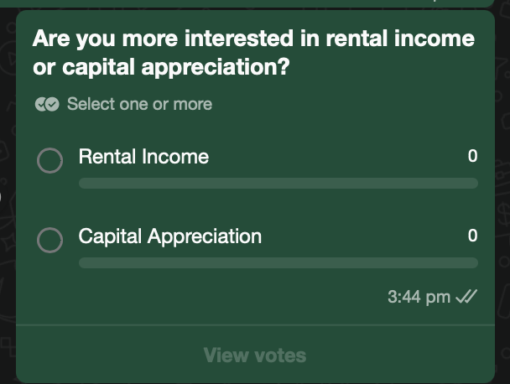
Don’t choose between rental income and capital appreciation.
Choose a property that gives you both.
This project is designed to provide both income and growth.
Let me show you why, how, and what makes this project different.
And Can Do First Try Appointment
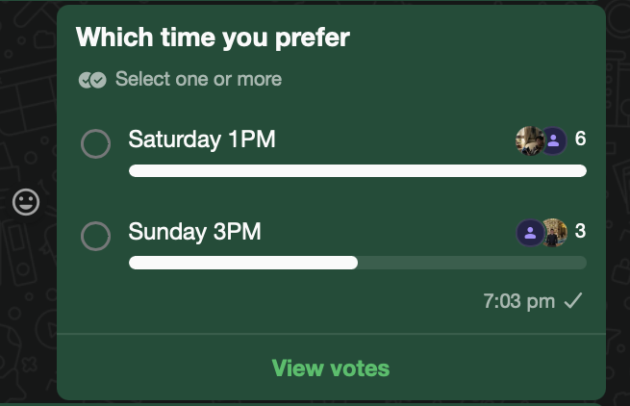
I will help you slot a unit into the system first.
Currently, we are running a campaign called “50 NPC”, which allows buyers to enter at the lowest price with legal fees fully covered, including Marriott standard ID, renovation, and furniture package.
So far, 42 units have already been taken, and only a few units are left under this campaign.
I think it would be easier if I explained this to you over a short WhatsApp call. When would be a convenient time for you?
📪🤝🏻Please read this before you sleep tonight.🤝🏻
After This Can Send This Massege
Which part of U Want To Know More First Before Your Appointment?
1) What Is The Return For The One And Only?
2) Project Surrounding Rental Rate?
3) Who Will Help Me Manage My Unit?
Step 6
-Return Surrounding -W hotel, etc
-Return Project
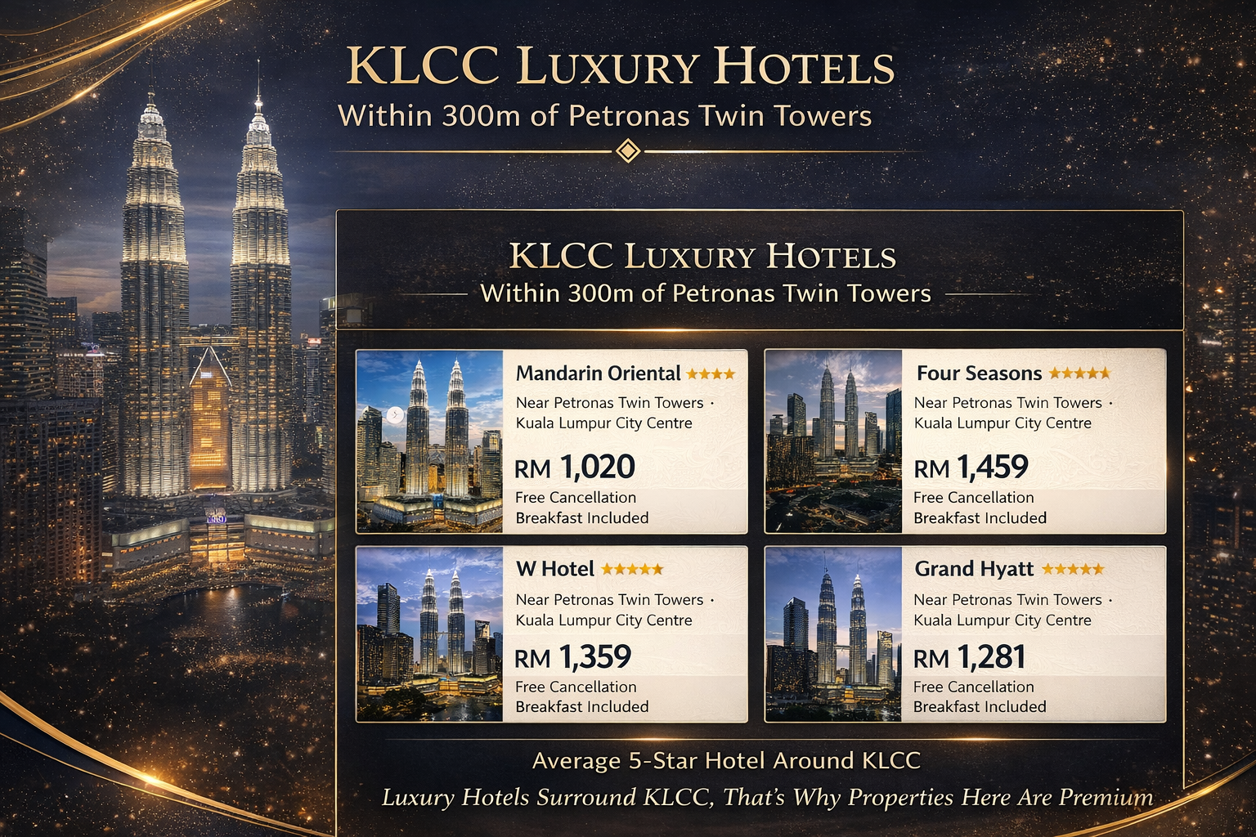
🌆KLCC 5-star hotels start from RM1,000+ per night？

🏨 Mandarin Oriental RM1,020++/night
🏨 W Hotel, RM1,359++/night
🏨 Four Seasons, RM1,459++/night
🏨 Grand Hyatt, RM1,281++/night
This isn’t about price —
it’s about location value.
🏨 All located around Petronas Twin Towers
🏨 Within 300m of world-class hotel brands
🏨 A hub for global tourists & high-net-worth individuals
👉 Because this is the core of Kuala Lumpur
📈 Property value always follows location
✨ Want to understand the KLCC investment logic?
DM me — I’ll show you how it really works ✨
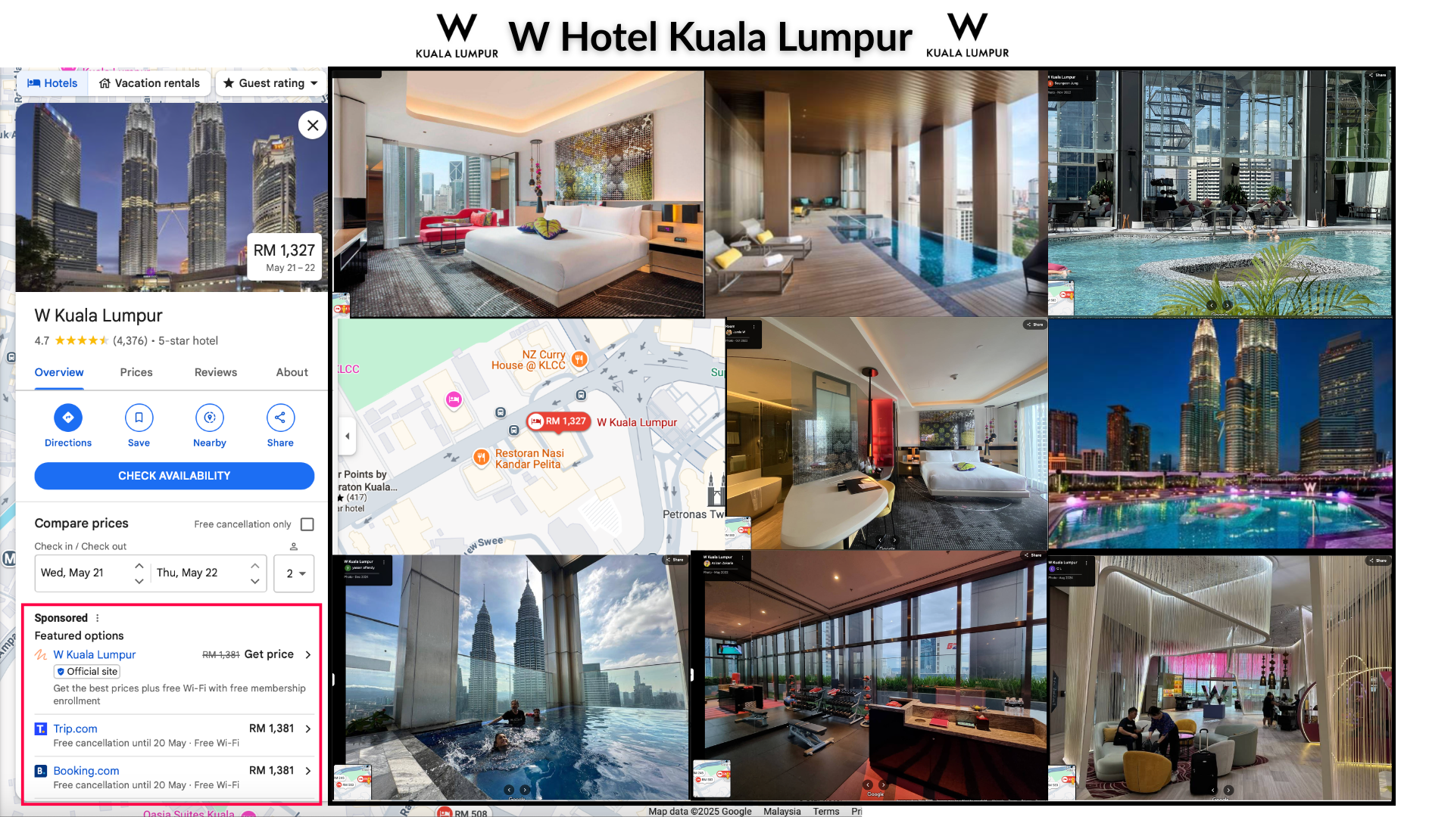
Why are people willing to stay at the W Hotel?

Because they are paying for:

🚶‍♂️Beside Iconic Towers, walking distance to KLCC
🌟 Luxury 5-star Facilities
📸 Instagrammable Pictures
✨️Premium City View
🛎 5 Star Hotel Services

They don't just pay for temporary stays, they pay a premium price to have an unforgettable experience 💯
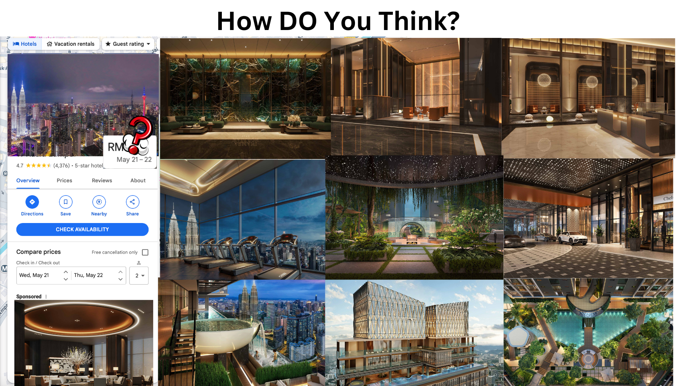
We Build. We Innovate. We Deliver.
The One & Only Residence

You are getting:

🏊‍♂️ Malaysia Tallest Sky Infinity Swimming Pool
🌴 Bali Sky Experience Deck
🌉 Next to KLCC with a Direct Link Bridge
✨️ Luxury 6 Star Concept
🏨 Services provided by Prestigious Hotel Brand
🌇 ICONIC Building in CBD Area
Only RM 1700 PSFT Can Own WorldClass Property, Fast Reply To Make Appointment To Know More. Entry A Price With RM890K(USD 220K) Only ‼️‼️
Step 7
-Our layout Efficiency
Summarry
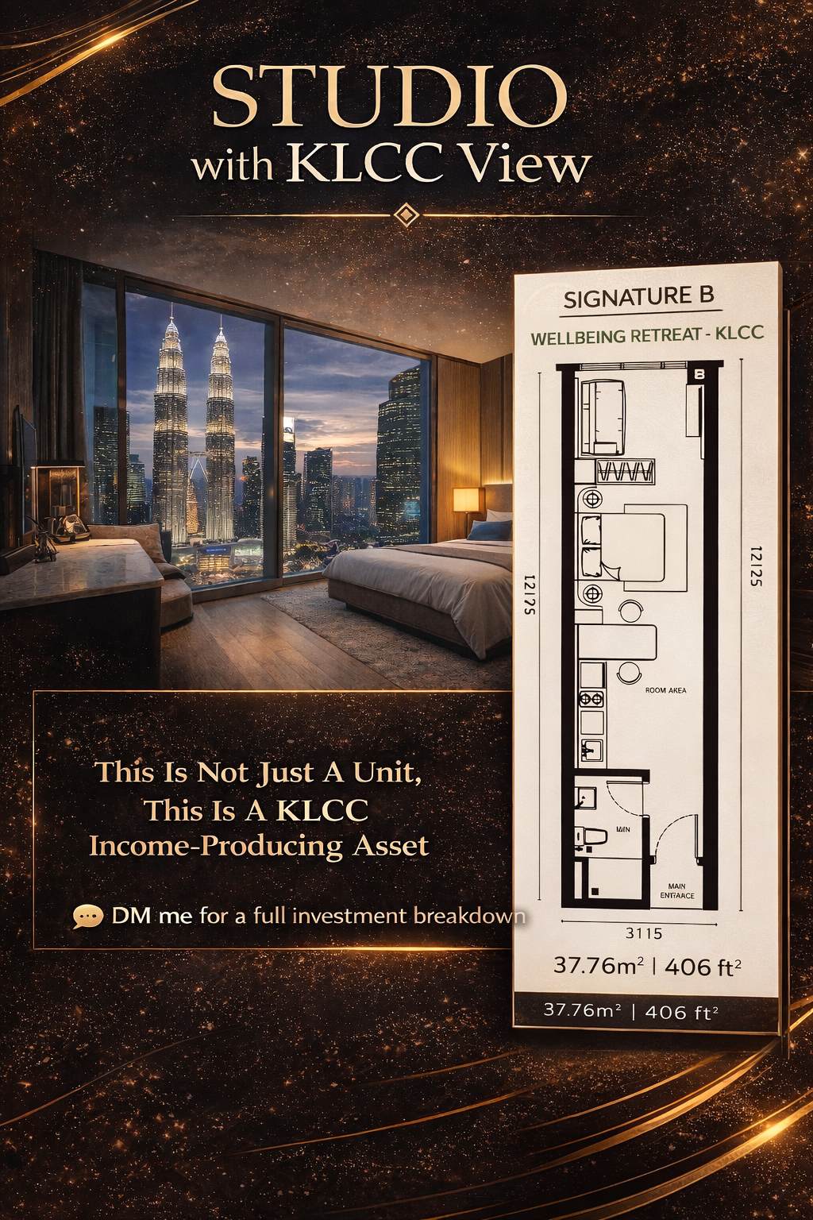
✨Studio with KLCC View
💰 Investment Highlights 💰
- Monthly Installment: RM4,000
- Rental Per Night: RM800
- Average Occupancy Rate: 80% / 24Nights

📈 Potential Earnings:
RM800 x 24 days = RM19,200 per month

📊 ROI : 16%
Break Even Point: 6year‼️
📊 Appreciation Gaining:
- KLCC Market RM3300 Per Sqft
- Entry Level RM2233 Per Sqft
Immediate Capital Gain
= RM1067PSF x 406sqft
= RM433,202 🤩
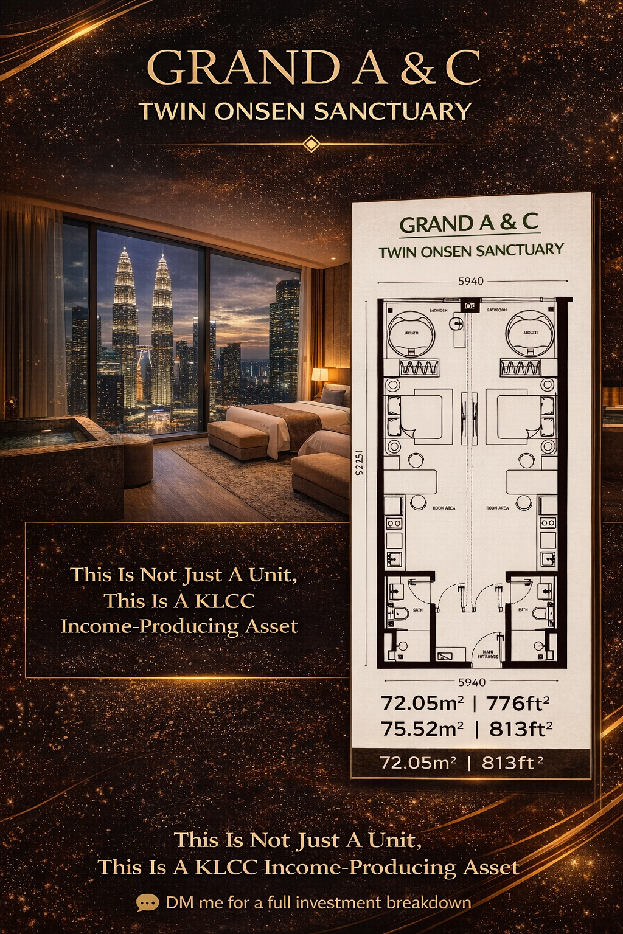
🛁Dualkey with Jacuzzi facing KLCC View
💰 Investment Highlights 💰
- Monthly Installment: RM8,300
- Expected Rental Per Night: RM1,000 x 2 (Dual-Key)
- Average Occupancy Rate: 80% / 24Nights

📈 Rental Earnings:
RM2,000 x 24 days =
RM48,000 per month

📊 ROI : 20%
Break Even Point: 5year‼️
📊 Appreciation Gaining:
- KLCC Market RM3300 Per Sqft
- Entry Level RM2350 Per Sqft
Immediate Capital Gain
= RM950PSF x 813sqft
= RM772,350 🤩
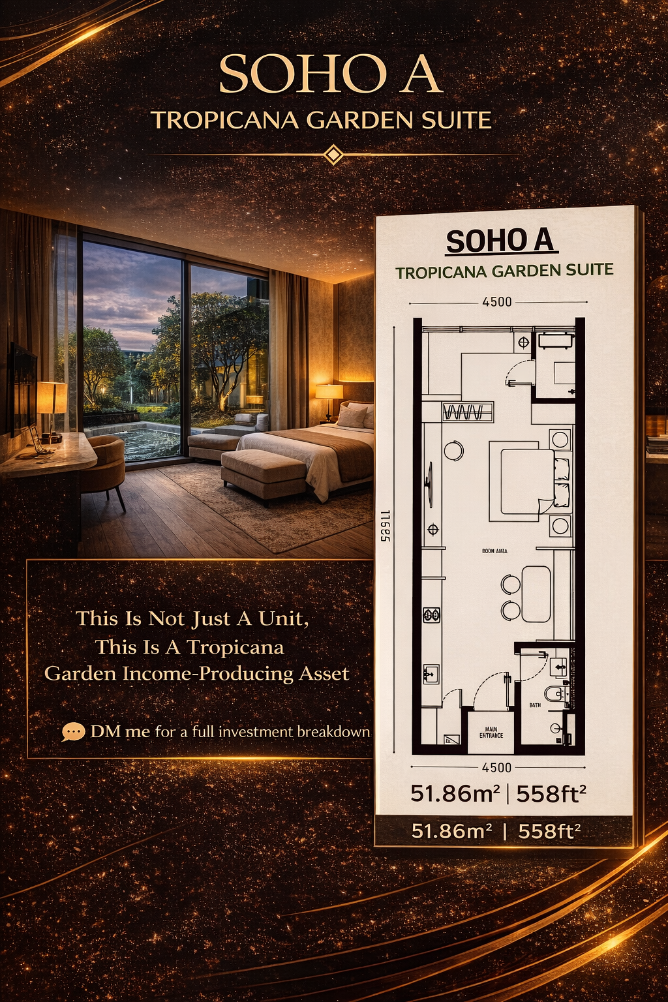
✨Studio with Tropicana Garden View

💰 Investment Highlights 💰
- Monthly Installment: RM4,200
- Rental Per Night: RM600
- Average Occupancy Rate: 80% / 24Nights

📈 Potential Earnings:
RM600 x 24 days = RM14,400 per month

📊 ROI : 18%
Break Even Point: 5year 6months
📊 Appreciation Gaining:
- KLCC Market RM3300 Per Sqft
- Entry Level RM1700 Per Sqft
Immediate Capital Gain
= RM1600PSF x 558sqft
=RM892,800🤩
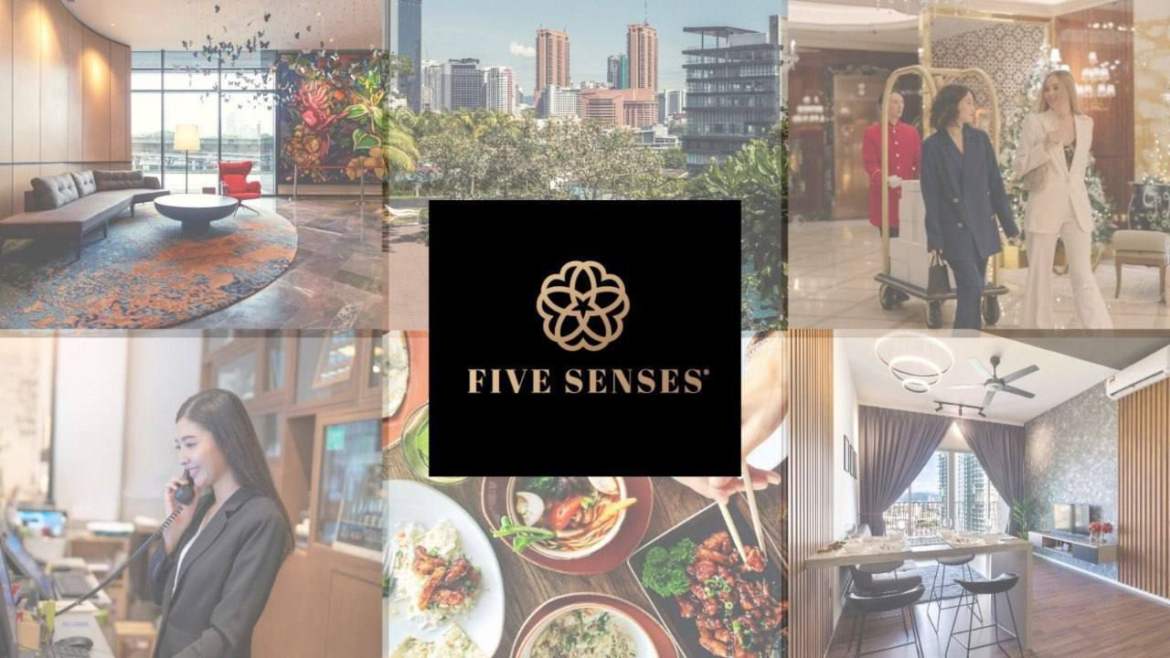
Who Will Manage Your Property?
Because Management Determines Your Returns.
Exclusive Operator ✨

Managed under Five Senses, the one & only partner of HVMI by Marriott Bonvoy in Malaysia🇲🇾

✅Maximise ROI 14-18%
✅Hotel Operating System
✅Fully Automated and Transparent

❌Price Wars
❌Bad reputation
❌Bad Service Quality
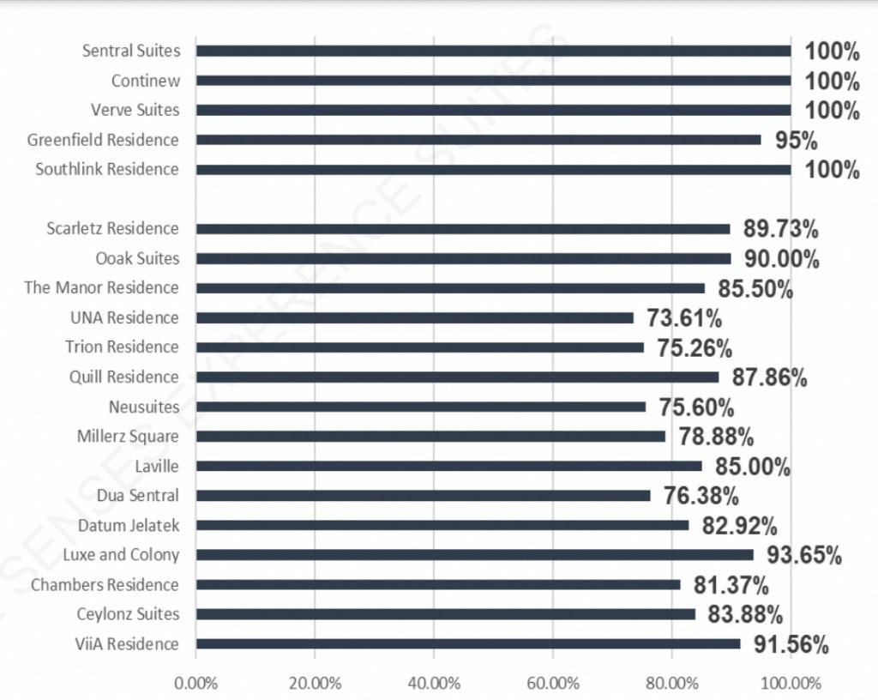
📊 Track Record and Building Performances 📈

🤔 How Five Senses success in the Market ???

✅ Average Occupancy Rates up to 8️⃣8️⃣% in 2023
✅ Average 4.8/5.0 room ratings
✅ More than 1️⃣8️⃣5️⃣0️⃣ rooms in Klang Valley
✅ Unique Step-Up Pricing Strategies
✅ Highest Profit Sharing Margin

❌Scattered Operator
❌Cheap cheap ID design
❌Low-cost apartment
❌Bad Operate Record

Win-win Situation with Five Senses, where luxury meets profitability❤‍🔥
Schedule an appointment to discover how Pool Sharing, MPA & MRO strategies can maximize your returns.
Step 8
You Need To Know More About Payment Progress?
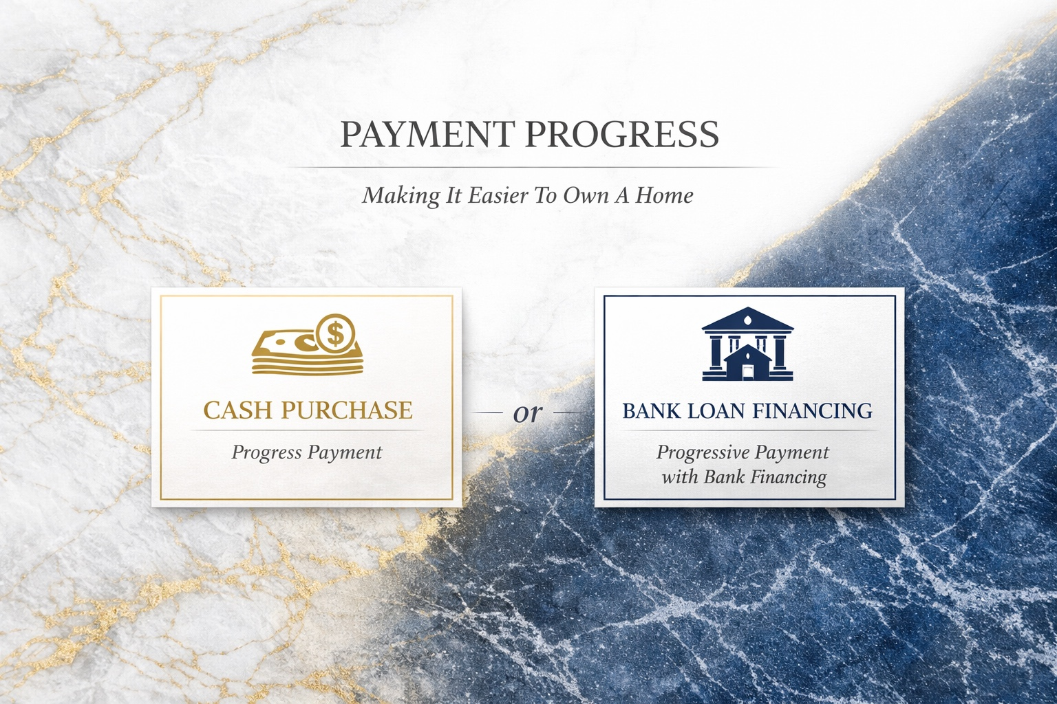
Payment Progress Structure
(i) Cash buy
- This payment structure is a 0% Interest Progressive Payment where payments are tied to the construction progress and directly pay to developer, spanning 3 years, instead of lumpsum the full amount upfront. You pay in stages according to the billing schedule as the building progresses. This ensures that your investment is aligned with the actual completion of the property.🤝

(ii) Mortgage Loan
- Borrow loan with bank, loan margin usually around 50%~70%, or can up to 80%. Averagely interest is 4.1% same as local offer, can be lower or higher depends on financial profile, scoring & bank special package. We also offer Developer Loan with lower interest rate 2% and up to 10% loan margin. Starting installments start after VP (handover).

Example
Installment: RM4000
So after VP in 2029, you will start to pay RM4000 monthly to the bank and starting to run the investment.

